# **VEDBÄK Rug, low pile, multi colour**

**Product details $650**

There’s always something new to notice and treasure thanks to the detailed oriental pattern.

**Materials & care**

100% polypropylene

Do not wash. Do not bleach. Do not tumble dry. Do not iron. Do not dry-cleaned spots; remove immediately by scraping carefully towards the middle of the spot. Wet spots; do not rub. Absorb with paper towels, damp with cloth and mild detergent. Professional carpet cleaning when needed. Always use the standard floorhead, never the rotating brush, when vacuum cleaning the rug.

## Product size

**Length:**

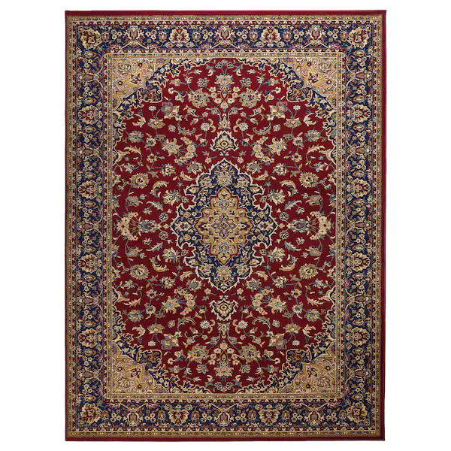230 cm (7 ' 7 ")

**Width:**

170 cm (5 ' 7 ")

**Thickness:**

15 mm (½ ")

**Area:**

3.91 m² (42.09 sq. feet)

**Surface density:**

2300 g/m² (7.54 oz/sq. ft)

**Pile coverage:**

1300 g/m² (4.26 oz/sq. ft)

**Pile thickness:**

11 mm (½ ")

-